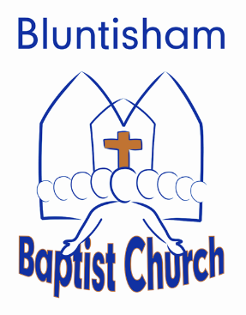

Order of Service 25th December 2024
Advent – Christmas Day

Welcome and lighting
of Advent candles: Rob

Songs: Joy to the World

Christmas Presents: Rob & Shell + Congregation

Song: Angels from the Realms of Glory

Readings: Luke 2:1-7 Rob
Matthew 2:1-12

Sermon: Rob

Video: Down to Earth Christmas excerpt

Song: O Come all Ye Faithful

Close and blessing: Peter

