A Self-Help Guide
For dealing with your debt

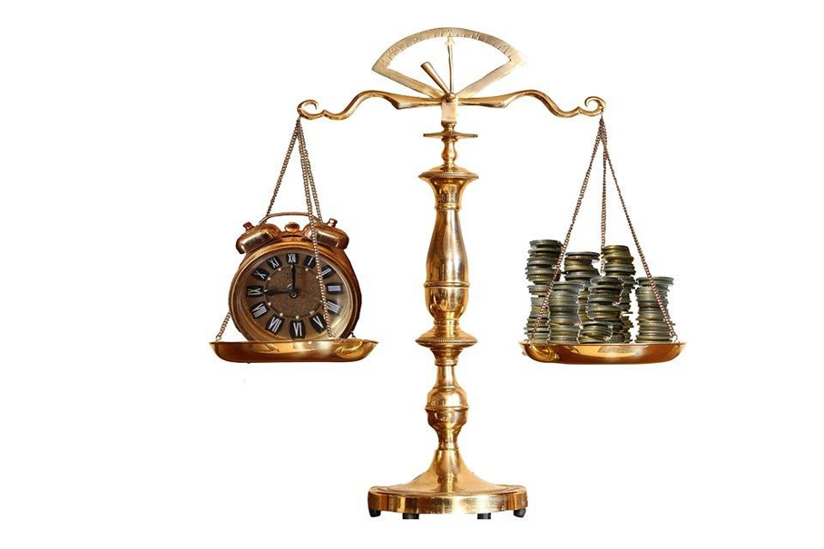

Failing to plan is planning to fail. Benjamin Franklin

Thinking about money

Introduction

This guide is designed to help you deal with personal debt (or improve your personal finances ) as there are many things you can do to regain control of your financial situation. Admitting that you are struggling and seeking help is an important first step towards resolving your debt problems. Don’t be embarrassed or ashamed to disclose all your debts and financial difficulties because ignoring the problem and not replying to correspondence will only make things worse. Your problems will not go away without specific remedial action.

Here are some positive things you can do; most of which are explained in more detail later in this document:

Stay calm and try not to feel guilty or afraid, even when threats are being made. Advice and support is available to guide you through your situation.

Don’t be tempted to borrow more money to pay off existing debts especially from payday loan companies– this eventually creates even more problems –seek free independent advice first.

Make a list of all your creditors and debts.

Prepare a statement of your financial position, detailing your income, living expenses and other commitments, and the balance (if any) available to clear your debts.

Communicate with your creditors so that they are aware of your situation –they will usually respond sympathetically to genuine problems once they are aware of them.

Communicate with your family and friends so that you can share your problems and work together
towards a solution.

Communicate with other agencies who can give you specialist advice –they should not charge for their
services.

Money problems often arise from or lead to family, health or emotional pressures, and it is Important that you seek professional help for these related problems too.

KEEP GOING! Don’t despair – clearing your debts can be a long process but the end result will be
worthwhile and will put you back in control of your financial situation and life.

Step One - Contact all your creditors

Creditors cannot help you unless they are aware of your difficulties and circumstances. You may also need to ask them to confirm full details of the amount owing, actual arrears, penalty charges etc. The following is a typical letter you may use:



Your Address

Date

Dear Sirs,

Account/Agreement/Reference Number

I am currently experiencing financial difficulties due to................
and I am therefore unable to maintain the full payment on my account. I am trying to resolve
my situation and will send you a financial statement as soon as possible with the best
payment offer I can manage.

Please may I have the following information so that I may draw up a schedule of all my debts
and make appropriate offers to my creditors:

Type of agreement (secured/unsecured)
Balance owing
Terms of repayment and interest/penalties accruing
Arrears
Any insurance policy attached to the agreement

To this end, we would appreciate if you could hold any action on the above
account for a period of at least 28 days.

Also, during this period, could you please freeze interest and/or any other charges
accruing on the above account?

I look forward to hearing from you as soon as possible and I will write to you again as
soon as I have received replies from all my creditors.

Yours faithfully
Draft Letter 1

When all the replies have been received, draw up a schedule of your debts and divide them between PRIORITY and SECONDARY creditors (for an explanation of creditors see STEP 2 on page 5).

It is essential at this stage to mark any debts where court orders (County Court Judgments or CCJs) have been made, or a claim form received and seek specialist help as these debts need immediate attention. Keep copies of all correspondence both sent and received. If any agreements are subsequently made by telephone get the name of the person you spoke to and ensure that the agreement is confirmed in writing.

It is important to check that you are actually responsible for all your debts. A husband and wife are not responsible for each other’s debts unless they have both signed the agreement (except for Council Tax), and you cannot inherit a dead person’s debts.

You should also check the amount being claimed to ensure all the payments you have made have been deducted and challenge any excessive interest or penalty charges. If you are unclear about any interest or penalty charges, ask the creditor for an explanation and challenge them if you believe them to be wrong.

Sort any paperwork you have for each creditor into separate piles and keep them separate from now
on.
Look out for any ‘default notices’ or ‘Court Summons’ - they may need to be dealt with quickly

Make a list of all your debts (using the sheet at the back of this document) with the address, reference number, and the amount you owe. If you are in doubt of the exact amount you owe to any creditor, send the Draft Letter 1.

Now add together the total amount owed - don’t panic! This might be more than you expect

Once you have received all your replies and made your list of creditors you need to sort them into categories. Some called priority debts will need dealing with sooner than others because of the possible consequences which we will outline in the next step.

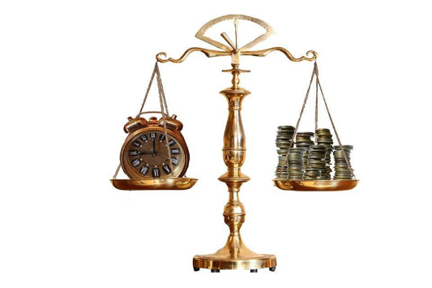

Step Two – Decide Priorities
Some debts carry more severe penalties than others and this means that they must be dealt with first. Priority treatment is not determined by the size of the debt, the period or amount of arrears or the threats being made, but by the actual legal remedy the creditor has against you for recovery. A PRIORITY debt is usually defined as one where non-payment can result in you:

losing your home
losing essential goods or services.
being imprisoned

Below is a list of priority debts and the legal consequences of non-payment.



Type of debt

Final sanction for non-payment

Mortgage/secured loan

Loss of house

Rent

Eviction

Gas/electricity

Disconnection/fitting of prepayment meter

Water
Since the Water Act, 1999, the supply cannot
be disconnected, but we recommend that this
is regarded as essential expenditure, and
treated as a priority payment.

Council tax
Taken from wages/benefits; bailiffs.
imprisonment

CSA/maintenance orders

Taken from wages/benefits; imprisonment

Magistrate fines

Bailiffs; imprisonment

Inland Revenue and VAT

Bailiffs; bankruptcy, imprisonment

TV Licence

Fine

Priority creditors must be dealt with before any offers or payments are made on SECONDARY debts. SECONDARY debts are all those which do not carry the above sanctions. For example:



Type of debt

Final sanction for non-payment

Telephone Arrears

Disconnection of service

Store Card

County Court Judgement

Credit Card

County Court Judgement

Unsecured Personal Loan
County Court Judgement

Credit Sale
County Court Judgement

Hire Purchase*

Loss of Goods

Catalogue Arrears**

County Court Judgement

Loan from Family/Friends***

County Court Judgement

Loan Shark***

Not legally enforceable unless licensed

* If the threatened goods are an essential requirement, for example a washing machine or car needed for work, such a debt must be treated as priority, but if you have paid less than one third of the total owed under the hire purchase agreement the creditor can repossess the goods without a court order.

** Catalogue debts may be difficult to enforce as it is not always standard practice to complete a formal credit agreement, and creditors should be asked to produce a copy of this if proceedings are threatened.

*** Individual circumstances may suggest some other debts be treated as priority, although not legally enforceable, e.g. money owed to family, friends or loan sharks.

NB Provided you give the court all the details of your circumstances they should be able to work out a repayment program that you can afford. It is only when you default on a court order that goods can be seized, bailiffs sent in or bankruptcy procedures started against you. 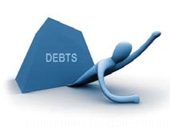

Step Three – Prepare a Financial Statement

It is essential that you now prepare a statement of your actual current financial position. A specimen statement is shown on page 9 and may be adapted to suit your particular situation.

Your statement must include all income received from whatever source and all money going out and to where. When completing this form use either weekly or monthly figures, but don’t mix them and mark clearly on the statement which basis you have used.

To change weekly figures to monthly, multiply by 52 and then divide by 12.

To change monthly figures to weekly multiply by 12 and then divide by 52.

Annual payments such as TV licence, road tax, insurance premiums etc. should be divided by 12 to give the monthly amount or by 52 for the weekly figure. Also allow for irregular, and often unexpected, expenditure such as car and house maintenance, repairs and replacements.

It is important to take everything into account, but don’t include payments for arrears or secondary creditors at this stage because you need to know the total money you have available (if any) to make offers to them.

Income

All income shown should be the actual money you receive, after tax and NI has been taken off.

Remember to include any social security benefits including child benefit and any other money regularly coming into the household e.g. maintenance.

Expenditure

When you are working out your expenditure remember to include your irregular purchases, e.g. vet fees if you have pet, dental costs, hairdressers.

When filling in the motor expenses allow money for maintenance as well as tax, insurance, M.O.T. and fuel.

When filling in housekeeping, do not base it on the lowest amount you have paid recently, this would not be a realistic figure.

The form might not include spaces for all your expenditure but remember to add them also.

Record your usual rent or mortgage payments, any secured loan payment, water, gas, electricity and council tax, not including any arrears.

Also, if applicable put down magistrates’ court fines, maintenance or CSA payments and essential hire purchase costs (e.g. car needed for work but not Hi Fi equipment, furniture etc.).

Do not put down your payments for unsecured loans, credit cards, overdrafts, store cards or catalogue accounts, these will get a share of what is left over once you have sorted out your priority debts.
Now, add up your income and expenditure - then subtract your total expenditure from your total income, this amount is called your ‘disposable income’ and is available to pay your creditors.
You might find you don’t have any ‘disposable income’, if this is so, check back through your outgoings and see if there is any way you can cut down. If there isn’t any ‘disposable income’ you will need to write to your creditors and tell them why using Draft Letter 2.



Your Address
Date

Dear Sirs,

Account/Agreement/Reference Number

Thank you for your letter providing me/us with details of my/our account with you. I/we
have now received all the information necessary from my/our other creditors to enable
me/us to make an assessment of my/our current financial affairs.

Unfortunately, as you can see I/we am/are at the moment unemployed/off sick/on a low
income and have no disposable income to distribute to my/our non-priority creditors. I/we
would therefore ask you to accept a token payment of £1.00 per monthly until my/our
circumstances improve.

I/we will contact you again as soon as there is any change and meanwhile thank you for
your assistance in this matter.

Yours faithfully

Draft Letter 2 – Please adapt for your own requirements

On the next page is a Financial Statement – Please photocopy or fill in using pencil first.
Electronic copies are also available on request.

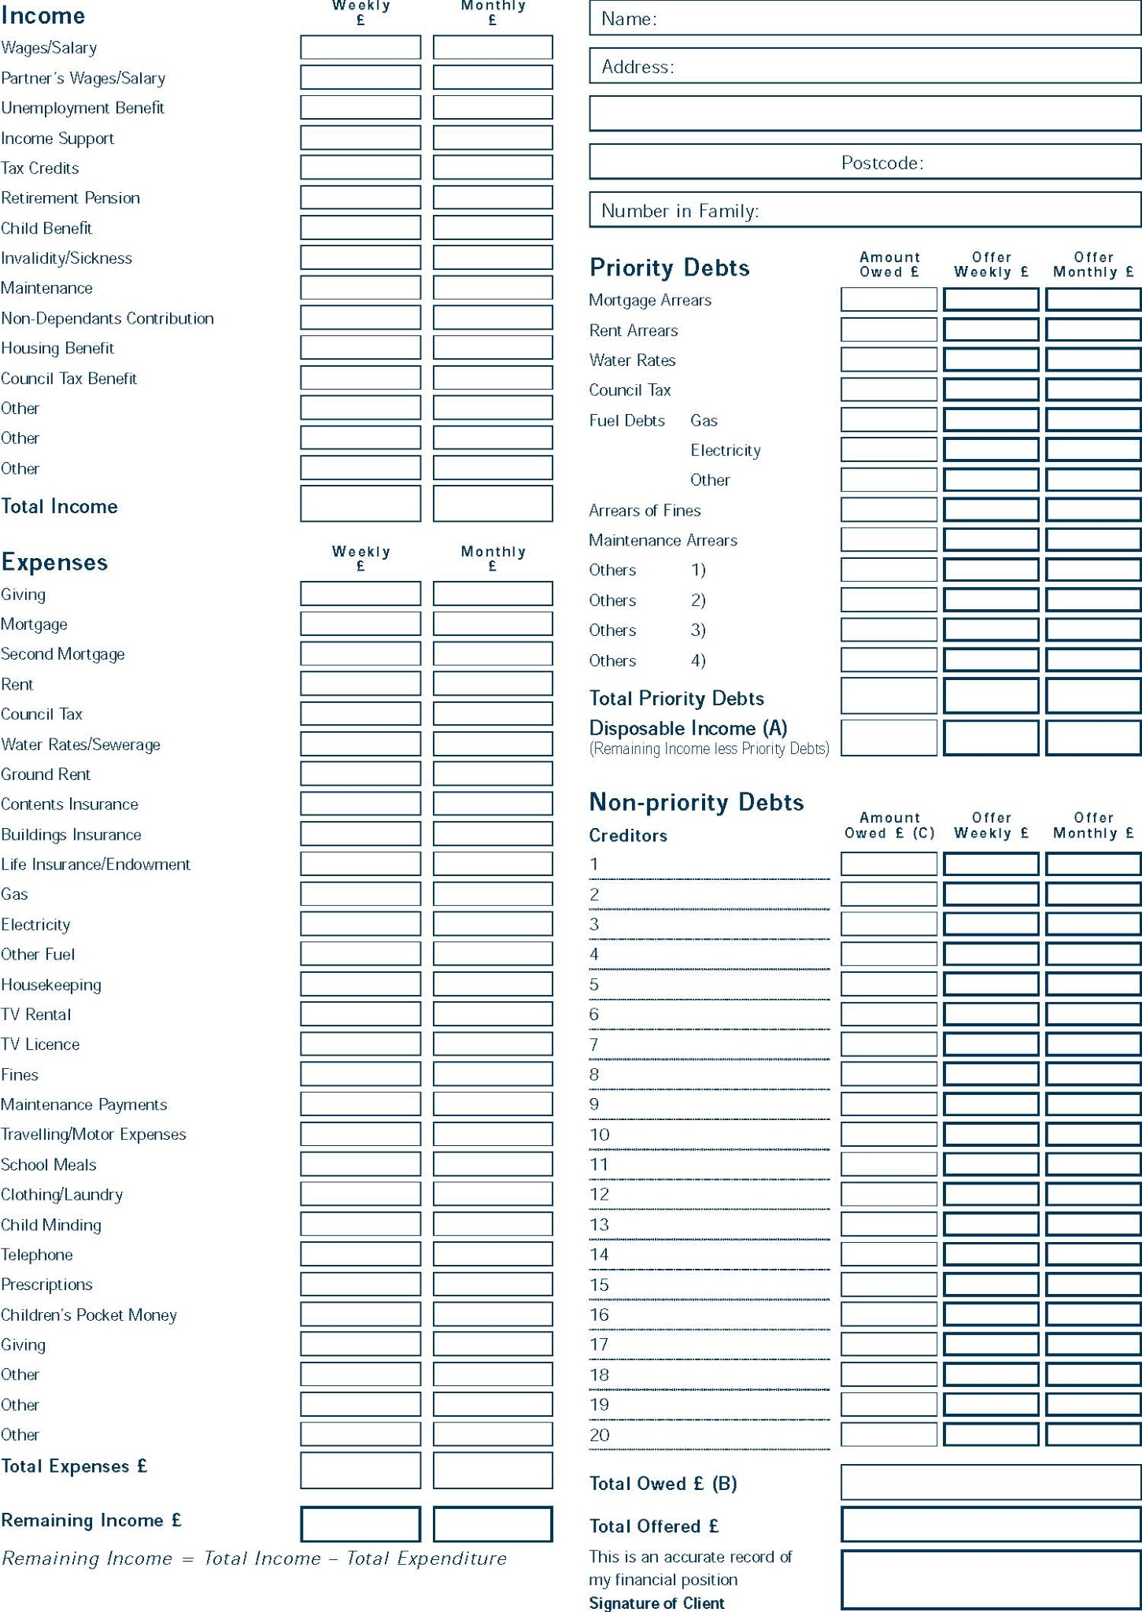

Step Four - Negotiate with your Priority Creditors

If you are in arrears you will need to negotiate with your priority creditors first and this should be done quickly to prevent implementation of their sanctions. Even if legal proceedings for recovery have commenced it is never too late to make an offer and seek a voluntary agreement.
List all your priority debts and send this schedule, along with your financial statement, to each priority creditor. This letter should detail the reasons for your financial difficulties and include a reasonable offer for payment of arrears, provided there is surplus money available. A suggested letter is shown below.

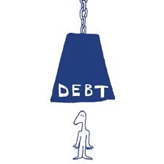
Draft Letter 3

Your Address
Date

Dear Sirs,

Account/Agreement/Reference Number

I am experiencing financial difficulties because.....................................

I enclose a financial statement detailing my current situation together with a schedule of all
my priority creditors.

You will appreciate that it is necessary for me to make an offer to each of these creditors
therefore, I am able to pay you £...... per week/month

If you will confirm your agreement in writing, I will commence payments immediately.

Please also advise me of the method and due date for such payments.

Yours faithfully

Step Five - Negotiate with your Secondary Creditors

After agreeing offers of repayment for all your priority debts, your financial statement should be updated to see if you have any disposable income to pay your non-priority debts. The fairest way to divide this amount (if any) amongst the secondary creditors is in proportion to the total amount they are owed. List these remaining debts on a summary sheet and add up the total of the secondary debts. The total available disposable income is then apportioned to these creditors by the following method:


Individual Debt

X Disposable Income = Offer
Total Debts
The example given below assumes you have £100.00 per month available for all secondary creditors:


ABC Catalogue:
£2,000.00
X £100.00 = £20.00
£10,000.00

Northern Loans:

£3,000.00

X £100.00 = £30.00
£10,000.00



SCHEDULE OF SECONDARY CREDITORS
Name:
Date:
CREDITOR

AMOUNT OWED
OFFER

Per Month £
ABC Catalogue

2
,000.00

20.00

Northern Loans

,000.00
3

30.00

Right Car Finance

1
,000.00

10.00

Flexible Credit Card

,000.00
4

40.00

TOTAL

10
,000.00

100.00

You may find it helpful to use a calculator to complete this schedule.

Using the figures you have calculated you can make an offer to each secondary creditor. A typical letter is shown below and this should be supported by a copy of the debt schedule and your financial statement.


Draft Letter 4
Your Address
Date

Dear Sirs,

Account/Agreement/Reference Number

You will be aware from my earlier letter that I am experiencing financial difficulties due
to..................................................................

I enclose a copy of my current financial statement which includes payment of arrears to my
priority creditors. I also enclose a schedule of all my secondary debts from which you will see
the available money has been apportioned on a pro rata basis.

I ask that you accept this offer of £...... per month and stop interest or other charges
accruing in order that the payments will begin to reduce the debt.

Please confirm your acceptance in writing and advise me how the payments should be made.

Thank you in anticipation.

Yours faithfully

Notes for Negotiating with your Creditors:

You should not offer all your available income to one creditor.

Start your negotiations with the debt nearest to its final sanction.

Don’t feel obliged or pressurised to pay more than you can afford, as it is important to sustain the payments once agreed.

Do not divulge account and reference details to anyone other than the creditor concerned.

Even if creditors don’t agree to your initial offer start paying as it will begin to reduce your arrears and may persuade them to change their minds if they see that you are serious in your intentions.

Ensure that you get a receipt for all payments made and any verbal agreements must be confirmed in writing.

As payment is agreed with each creditor you should include this in your financial statement so that other creditors can see your current situation and you can adjust to living within your new budget.
If you have no surplus income for priority creditors after re-assessing your budget, you must still contact them and support your position with your financial statement. You should remember that some creditors have the legal right to make direct deductions from wages or income support via the Department for Work and Pensions (DWP).
For ‘fuel’ debts (gas and electricity), pre-payment meters allow the arrears to be collected over a period of time and are a way of avoiding disconnection.
For mortgages and secured loans, the following options should be explored:
Never abandon your property or hand the keys back to the lender.

Always contact your mortgage lender at the first sign of a problem and continue to keep them informed of any changes in your circumstances.

‘Interest only’ or other reduced payments for a limited period of time.

Capitalise the arrears.

If your financial situation is improving, seek to repay the arrears over an agreed period of time.

Consider re-mortgaging on a different basis, e.g. transferring from an endowment to a repayment mortgage, but be careful to check and compare terms and conditions, initial and longer-term interest rates, early redemption penalties, administration charges etc.

Voluntary sale of the home will usually produce a higher price than forced sale after repossession, but consideration must first be given to alternative accommodation as the local authority may decide that you have intentionally made yourself homeless. Such a sale may not always produce sufficient equity to clear the outstanding mortgage/loan and you may still be legally liable for the balance, even if the lender agreed to the sale.

It is important that creditors can see that you have treated each of them fairly so don’t be pressurised or threatened into increasing individual offers at the expense of other creditors.

There is usually a reluctance to freeze interest and other charges but there is little point in paying if the outstanding balance continues to rise so try writing again as follows:



Your Address
Date

Dear Sirs,

Account/Agreement/Reference Number

Thank you for accepting my offer of repayment but I am disappointed that you have not
agreed to freeze the interest on the account.

As you will appreciate, if the interest is not stopped then the balance on the account will
continue to rise and I will never be able to repay the debt. I would ask, therefore, that you
reconsider your decision and advise me accordingly.

Yours faithfully
Draft Letter 5

If your bank is a secondary creditor, it may be necessary to open an account elsewhere if possible and redirect your wages so that you can have access to them. Direct debits will also need to be transferred as the bank may stop paying them.
Start payments as soon as they are agreed in writing with your creditors and remember that keeping up regular payments is essential, even if they are small.
If your circumstances deteriorate further and you cannot sustain payments then prepare a revised financial statement, re-calculate your offers in line with your current available disposable income and write to your creditors again explaining the change in your circumstances.

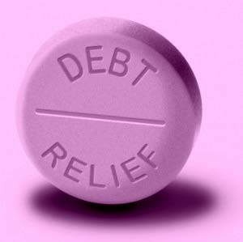

If a creditor will not accept your initial offer you can write to them as follows:



Your Address
Date

Dear Sirs,

Account/Agreement/Reference Number

Thank you for your letter dated............................

I am sorry that you feel unable to accept my offer. The majority (or all) of my other creditors
have accepted and payments to them have commenced.

I cannot offer you more as you will see from my financial statement that I have only
£................. in total to divide between all my creditors and it would be unfair to favour your
company at the expense of others who have agreed to my offer.

Please reconsider your decision in the light of what the other creditors have accepted.

Yours faithfully

Often creditors will agree to reduced payments for a limited period of time, for example three to six months. If your circumstances haven’t improved by the end of this period, then let them know and continue existing payments. Otherwise prepare an updated financial statement and re-calculate your offers as explained above.
If you have no disposable income for secondary creditors, then write and inform them explaining your circumstances and that you are sending your financial statement to confirm your situation.
Agree to contact them again if your circumstances improve. In the meantime, ask them to freeze interest charges. You could ask them to consider writing off the debt or accepting a reduced settlement, although they are unlikely to do so in the early stages. Make a token offer of payment to each creditor of £1 per month. Include the first payment with the letter and continue to make monthly payments. This shows that you want to do what you can to pay what is due.



What about Court Proceedings?

The aim of this document is to help you avoid court proceedings but what happens if negotiation fails and your creditors resort to legal action? It is not a crime just to owe money and with certain exceptions which are rare, (see page 5), you can’t go to prison if you are unable to pay.
Your case will normally be heard in the county court which is not a criminal court. The court is not there to punish you but to help you and ensure fairness between the borrower and lender. So don’t be afraid of court action – it can often help solve your problem because you do have some legal rights.
Always complete and return court documents within the specified time so that the court is aware of your problems and overall financial situation and will be able to take these into consideration when making an order.
Always attend court hearings to ensure that your case is properly represented. The case will normally be heard in a private room with officials who are used to dealing with these matters – they are not there to serve the interests of the creditor alone.
It is helpful to be represented in court, but don’t worry if you cannot afford a solicitor, just contact your local Citizens Advice Bureau or specialist debt advice service such as The Beacon Money Advice Centre, who may be able to arrange assistance or refer you to alternative agencies who can assist with court representation.

If court action is taken against you:

You will receive a claim form stating what your creditor claims from you.

If you do owe the money, return the form of reply attached to the claim form to the creditor saying how much you can pay. Complete the financial statement on the back of the claim form and make sure you explain your circumstances fully.

If you dispute some or all of the debt, say why on the form provided.

If the creditor accepts your offer, they will tell the court and you will then get an order (a judgment – CCJ) from the court telling you to pay at the rate you offered.

If the creditor refuses your offer the court decides how much you pay from the information you have provided. If they tell you to pay more than you have offered, you can ask for a hearing to explain your situation in more detail. You have fourteen days to ask for this. Alternatively, you can fill out form N245 obtainable online or from your local County Court

If necessary, seek advice in dealing with court documents but don’t ignore them otherwise a decision will be made without the court being aware of your actual circumstances and financial situation.

Special considerations apply if the court hearing is for re-possession of or eviction from your home – seek immediate help as there are still things you can do at this stage.

Other aspects of debt recovery procedures which you may become involved with are:

Debt Collection Agencies

Rather than accept your offer of repayment the creditor may refer your account to a debt collector. Do not be pressured, bullied or threatened by them into paying more than you can afford. Stand firm on your offer and refer to the financial statement sent to the creditor. Collectors have no legal right of entry to your home and cannot remove goods. Undue harassment is illegal and should be reported to your local Trading Standards Department.

Bailiffs

If you fail to make payments under a CCJ (England & Wales) or a Decree (Scotland) the court will grant a Warrant of Possession Order or Summary Warrant respectively. Bailiffs or Sheriff Officers may be directed by the court to implement the order by removing goods to the value of the debt and costs, dependent upon the administrative actions conducted by the creditor via the court. You do not have to let a bailiff into your home, and they cannot break in (unless they have entered previously for that debt). They can legally enter through a door or window that you have left open. Only bailiffs recovering debts owed to the State (e.g. Income Tax and VAT) can force entry to your home. Even at this late stage it may be possible to negotiate satisfactory terms for payment with the bailiff. As an alternative the court can grant an Attachment of Earnings Order to deduct money directly from your wages.

Credit Reference Agencies

They keep records of some unpaid debts and a register of all county court judgments. Most companies will check with an agency before giving credit. You can obtain a copy of your record from the Agency and if it is wrong it can be corrected and when you pay off a CCJ you can have your record marked accordingly.

Magistrates Court

Certain types of debt can be recovered through the Magistrates Court (e.g. council tax arrears and unpaid fines). The procedure will vary but once again you must respond to all court documents and immediately seek professional advice. The magistrates have the ultimate sanction of imprisonment for some debts, although this is only used as a last resort.

Administration Orders

If you have a number of small debts (maximum £5,000 in total) you can apply to the court for an Administration Order. This means that you pay the court one regular amount, and they distribute it to the creditors on your behalf, although a small charge is made. A court judgment has to be entered against you before you can apply.

Bankruptcy/Individual Voluntary Arrangement (IVA)

Bankruptcy is a way of dealing with debts, enabling you eventually to make a fresh start and, at the same time, making sure your assets are shared out fairly amongst your creditors. A number of assets are automatically protected under Bankruptcy/ Sequestration with the Official Receiver having discretion over others. However, you will probably lose some of your assets, there will be costs involved in the process and restrictions on your future activities so the situation needs very careful consideration, and you should seek professional advice before making a decision. Your creditors can also petition for a Bankruptcy Order and, if this is the case you need to seek help immediately.
An IVA is another way of resolving a debt problem. The equivalent in Scottish Law is a Trust Deed. Certain criteria must be met and there are costs involved. You must also have some means of making an offer to creditors. Seek professional advice before embarking on this complex procedure. The best people to see regarding an IVA/Trust Deed would be suitably qualified Insolvency Practitioners, Chartered Accountants or Solicitors. With regards to the way in which assets may be protected in an IVA/Trust Deed we suggest that you discuss this with the Insolvency Practitioner/Chartered Accountant who should be able to advise which assets could be excluded from the arrangement without detriment to the agreement.

What about the Future?

The path to clearing your debts, or even avoiding them, may be quite short for some. On the other hand, you could be faced with several years of hardship before you are able to clear them. In either case you need to identify the cause of your problem.
Most people fall into debt through no fault of their own. It is often as a result of redundancy or reduced working hours, illness or marriage breakdown. However, it may be that you found using credit cards was too easy or you were unable to resist offers of interest-free credit.
One of the key things to remember is that family pressures will arise. Not only will you have less money, but your stress and anxiety levels are likely to increase. It is important to realise that this is perfectly natural and understandable so please don’t be afraid to seek help and medical advice if necessary. Try to keep yourself occupied. You might find it helpful to join a local support group if there is one in your area. Here are a few practical suggestions for saving money and staying out of debt in the future:

Only buy on a cash basis – if you can’t afford something save up for it.

When you go to buy something ask yourself whether you really need it or just want it. Try waiting for thirty days before you buy anything and if you decide you are going to buy it try and obtain one or two quotations to compare prices.

When you go shopping prepare a list and keep to it.

Keep your financial statement up to date and live within it. Look for ways to improve your income whilst trying to reduce your expenditure.

Keep your own accounts and always check your bank statement.

REMEMBER – if debts start to build up again seek immediate help before things get too far out of hand.

Do’s and Don’ts



- DO be realistic – face up to your true situation and resolve to deal with it – using the help available to you.

- DO get in touch with your creditors immediately to explain your difficulties.

- DO give priority to those debts which may result in you losing your home, fuel supplies or your liberty.

- DO remember that your creditors prefer small payments regularly rather than larger, irregular payments that you cannot sustain.

- DO reply to creditors’ letters and court documents within the time period specified and let them have all the facts.

- DO keep copies of all correspondence, financial statements, debt schedules etc.

- DO attend and/or be represented at court hearings and take all relevant correspondence with you, including your current financial statement.

✘ DON’T ignore the problem – it won’t go away.

✘ DON’T give up trying to reach agreement with your creditors even if they are difficult and refuse your initial offers.

✘ DON’T be threatened or bullied into making promises which you cannot fulfil.

✘ DON’T borrow more money to pay off your debts, especially by taking on more credit or store cards.

✘ DON’T be afraid to ask for specialist advice – it’s FREE.

Above all be Honest

Glossary of terms

Arrears |  |  | The total amount of payments which are now overdue.
Court Summons |  |  | A set of forms giving a court hearing date and also inviting you to explain your financial circumstances so that the court can determine how much you can afford to pay.
Creditor |  |  | Someone who has lent money or goods to someone.
Debtor |  |  | Someone who has borrowed money or goods from someone.
Default Notice |  |  | An official form which must be issued by a creditor before court action can start. This applies to regulated loans (i.e. most loans of £15,000 or less).
Disposable Income |  |  | The income that is left over when your expenditure is subtracted from your income. Expenditure does not in this case include Non-Priority Debts.
Financial Statement |  |  | A summary of your income and expenditure, showing how much money, if any, is left over to pay off your debts. The Financial  Statement is central to any negotiation with creditors or courts.
Hire Purchase |  |  | A method of purchase often used to buy cars and household items, where the item is legally owned by the creditor until the end of the agreement. NB. This means even if the item is returned to the creditor the debt can still remain.
Non-Dependents Contribution |  |  | Someone living with you and contributing financially into the household.
Non-Priority Debts |  |  | Debts which do not put the borrower at serious risk if not paid. Such debts can lead to court action, but not to losing a house.
Priority Debts |  |  | Debts which put the borrower at risk of serious loss if not paid, such as losing a home, car, phone, water, gas or electricity supply etc. or going to prison.
Secured Loan |  |  | A loan guaranteed by some property of the borrower (usually a house). If the borrower doesn’t pay, the lender can take the property and sell it to pay off the debt.
Unsecured Loan |  |  | A loan which is not guaranteed by property.

Creditors List

This is for your own records. Use it as a means of collecting your information together and making sure you have all the details ready for use on the Financial Statement which you will send to all your creditors. All figures must be for the same time period – either weekly or monthly.

Name and address of creditor | Account number | Amount Owed £ | Proportion of Total debt | Total amount offered
Please photocopy if you have more than ten creditors

It is not unusual for people to find themselves in difficulty due to debt problems or they are facing difficult decisions regarding their finances. To help in such situations, the Bridge Debt Advice Service has produced this self help guide. It is a practical guide that offers clear, step-by-step advice on all the major difficulties…….
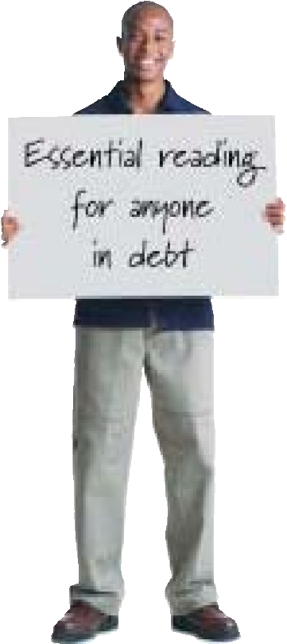

How to prepare a financial statement
How to prioritise your debts
How to negotiate with your creditors
Where you can go for help

This guide, which is essential reading for people who feel trapped by rising debt, also includes a number of ready- made letters for copying when writing to creditors.
The principles outlined in this guide may also be used to strengthen your financial position to avoid falling into debt or to improve quality of life.

Important Notice

Please note that this guide is for personal debt only and not for business debts. The Bridge Debt Advice Service cannot accept liability for any consequences of your dealing with your personal debt issues.



The Bridge Debt Advice Service
2 Burrel Road
St Ives Cambridgeshire PE27 3LE
info@tbdas.co.uk
Call 01480 498802

The Bridge Debt Advice Service is authorised and regulated by the Financial Conduct Authority to provide:

Provision of debt-adjusting on a non-commercial basis only.
Provision of debt-counselling on a non-commercial basis only

